### **Star of David Spinner**

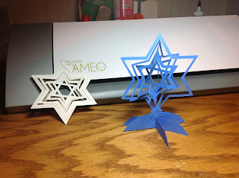

I created two versions of this star. One is a hanging ornament and the other is a desk model.  
  
 Here is the PDF. It is not a very good PDF as it does not show the lines correctly. All of the lines are connected except for the center points have a small gap. This small gap is where the paper is attached as a whole which allows for the spin to occur.

Assemble the star as shown in the picture below. Each star goes in the opposite direction to create the spinning effect.

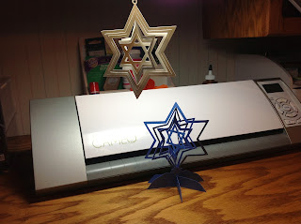

Happy Hanukkah to all my Jewish friends!

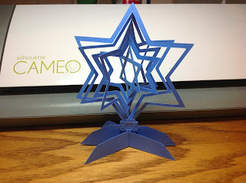

P.S. Check back later as I have quite a few more spinners to post but not enough time.